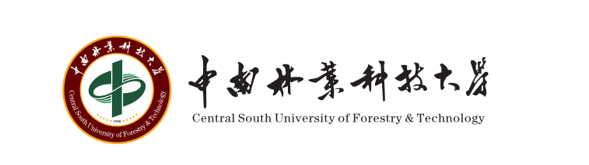
中南林业科技大学国际学生入学申请表
Central South University of Forestry and Technology
Application Form for International Student

个人信息 SECTION A –PERSONAL DETAILS
姓Surname/Family Name: |  |  |  |  | 名First Name, Second Name: |  |  |  |  |  |  |  |  | 性别Sex: |  | 照片Photo  (3cm*4cm)
国籍Nationality: |  | 出生地 Place of Birth |  |  |  | 护照号码Passport Number: |  |  |  | 护照有效期至 Date of Passport Expiry: |  |  |  | 出生日期Date of Birth:(DD-MM-YYYY)
宗教信仰Religion: | 婚姻状况Marital Status: |  | 个人特长Personal Talent: |  |  |  |  | 当前职业Current Occupation: |  |  | 学习或工作单位Institution or Employer:
家庭信息  Family Information | 父亲姓名 Father’s name: |  |  |  |  |  |  |  | 职业Occupation: |  |  | 联系方式Contact details:
家庭信息  Family Information | 母亲姓名 Mother’s name: |  |  |  |  |  |  |  | 职业Occupation: |  |  | 联系方式Contact details:
家庭信息  Family Information | 家庭经济收入  Family Finance Status
 | 家庭地址Family Address: |  |  |  |  |  |  |  |  |  |  |  |  |  | 邮政编码Zipcode:
联系电话Contact Tel: |  |  |  | 电子邮箱（必填）Applicant’s Contact e-mail (required): |  |  |  |  |  |  |  |  | 邮寄地址 Mailing Address (Required for posting admission letter):
学习类别Categories of International Students (please place a ✓ in the appropriate box below)
1. 汉语进修生Mandarin Chinese learner □ 2. 本科生Undergraduate □
3.硕士研究生 Master Candidate □ 4. 博士研究生Doctor Candidate □
5. 高级进修生General Advanced Student □

专业选择和学习期限SECTION B – COURSE AND PERIOD OF STUDY OPTION
专业名称COURSE. Please refer to our website http://lxsb.csuft.edu.cn for more information.
专业名称Title of Programme:

学习期限Proposed study date from (DD-MM-YYYY) to (DD-MM-YYYY)

教育背景SECTION C – EDUCATION BACKGROUND

请提供全部学习经历及相关证明，应届高中毕业生提交本人所在学校出具的预期毕业证明原件（仅接受中文版或英文版）。You should indicate here details of all education, academic and professional qualifications achieved/expected (please put official title of award) with the most recent first. Please attach photocopies of official transcripts / certificates (Original documents in languages other than Chinese and English should be accompanied by notarized documents).

时间From date  to date | 学校School / Institution  attended | 成绩单Transcript  (Official copy is required) | 学习专业 Major/Programme  studied | 毕业时间Date of  graduation

汉语或英语水平SECTION D –CHINESE / ENGLISH LANGUAGE ABILITY

你的最高学历教育阶段的授课语言是汉语还是英语？Is the teaching medium Chinese or English in your highest education? 汉语CHINESE □ 英语ENGLISH □

如果既不是汉语也不是英语，请提供HSK或IELTS、TOEFL或同等水平的语言证明。If NOT Chinese or English, give details of the HSK or IELTS, TOEFL certificate or equivalent proof:
考试名称Test Name | 考试成绩Test Score | 考试时间Date Test Taken

工作经历SECTION E-Please give details of any current / previous employment or internship.

工作单位Employer (with dates) | 工作时间Period of Employment | 主要职责Main Duties

经费来源SECTION F – FINANCIAL SUPPORT

Please indicate how you intend to finance your studies at CSUFT (please place a ✓ in the appropriate box below):
□ 自费Self funding
□ 部分奖学金Self funding with partial scholarship（please sign and date statement below)
Name of funding body :……………………………… Amount of partial scholarship award: ………………………

□ 第三方资助Third party funding, e.g. scholarship, employer, sponsor, research council
Name of funding body: ………………………………

如果想要获得中南林业科技大学奖学金，请尽量多地提供材料以证明你的优秀If funding by CSUFT, please provide documents as more as possible showing your excellence.

声明SECTION G – DECLARATION

在此，我郑重声明，上述内容真实有效，否则我愿意承担一切后果。I hereby confirm that the information I have provided on this form is true, complete and accurate and that no information material to this application has been omitted.

Signature: ………………………………………… ……………. Date: ………………………………………………….

